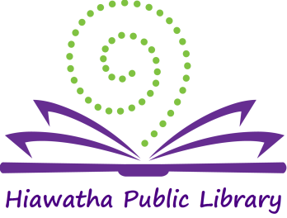

Library Board of Trustees Meeting

Location: Glenn Schminke Community Room
Date: February 13, 2018
Call to Order: 7:02 pm

- Call to Order – Roll Call Present: Matt Dunbar, Brenda Powers, Jerry Mohwinkle, and Karlene Nesslage. Also present: Jeaneal Weeks-HPL Director.
- Approval of Agenda
The Agenda was reviewed. Brenda Powers made a motion to accept the agenda, Matt Dunbar seconded and the motion was carried.

- Approval of Consent Agenda
  - Approval of bills
  - Minutes: January 9, 2018
  - Minutes: January 18, 2018
  - Library Director’s Report
  - Monthly Report
  - Annual Report
Unanimous approval was given for the Consent Agenda
- Old Business –
- Expansion update:
A Request was made to the Linn County Supervisors for funds for the expansion project. Fundraising continues. Jeaneal and the staff are looking at furnishings and shelving.

- Trustee Training:
Many trustees attended a webinar where Lance Werner, Executive Director of the Kent District Library in Michigan presented The Value of Personal Relationships in Advocacy on January 18th.
Upcoming webinars were discussed to continue training for the trustees.

- New Business –
  - Policy Review:
    - By-laws
    - Personnel policy
      - Full Time
      - Part-Time
    - Circulation policy
    - Collection development
    - Internet policy
    - Photo and Video Recording
Policies were reviewed and discussed. Karlene Nesslage made a motion to approve the policies, Matt Dunbar seconded and the motion carried.
    - Resolution:
Resolution 001-004 (amended)
Resolution Regarding Incentives Regarding Incentive Pay for Sunday Hours
Be it resolved that library employees receive incentive pay for working Sunday hours. Part-time employees (29 hours per week or fewer) will receive time and a half pay for Sunday hours worked. This excludes Page positions. Full time employees (30 hours per week or more) with the exemption of salaried employees will receive time and a half comp time for Sunday hours worked.

The changes to the resolution were discussed and approve by unanimous roll call.
  - Approval of County Contract:
The 2018 contract with Linn County was reviewed and approved by unanimous roll call.
  - Friends of the Library:
The Friends of the Library have recruited 3 new members and have started a new fundraiser.

- General Discussion – none
- President’s Report –
Update on the plaque for Janet Libe; plans are being finalized.
- Adjournment – Karlene Nesslage made a motion to adjourn the meeting, Brenda Powers seconded and the motion was carried. Meeting adjourned at 7:45 pm.

______________________
Brenda Powers, President
ATTEST:
___________________
Karlene Nesslage, Secretary

