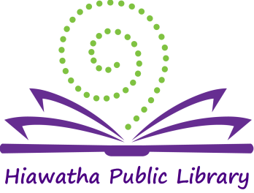

Library Board of Trustees Meeting

Location: Glenn Schminke Community Room
Date: June 20, 2018
Call to Order: 7:00 pm

- Call to Order – Roll Call Present: Matt Dunbar, Brenda Powers, Anna Ronnebaum, Sue Halter, and Karlene Nesslage. Also present: Jeaneal Weeks-HPL Director
- Approval of Agenda
The Agenda was reviewed. Brenda Powers made a motion to accept the agenda, Sue Halter seconded and the motion carried.

- Approval of Consent Agenda
  - Approval of bills
  - Minutes: May 8, 2018
  - Library Director’s Report
  - Monthly Report
Unanimous approval was given for the Consent Agenda
- New Business – None
Next month: Patron Conduct Policy and Elections
- Old Business – None
- General Discussion –
Anna reported that she attended the Friends of the Hiawatha Public Library board meeting. Book Sales are continuing.
The Niche Academy is also a good source of material for board member training.
Volunteer participation has increased recently.

- President’s Report –
There was discussion about additional training opportunities for board members. We will be planning another session soon.
Brenda shared a document with the terms of each of the Board members for information.

- Adjournment – Karlene Nesslage made a motion to adjourn the meeting, Matt Dunbar seconded and the motion was carried. Meeting adjourned at 7:24 pm.

______________________
Brenda Powers, President
ATTEST:
___________________
Karlene Nesslage, Secretary

