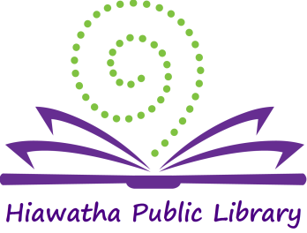

Library Board of Trustees Meeting

Location: Glenn Schminke Community Room
Date: May 8, 2018
Call to Order: 7:00 pm

- Call to Order – Roll Call Present: Matt Dunbar, Anna Ronnebaum, April Neuendorf, and Karlene Nesslage. Also present: Jeaneal Weeks-HPL Director, Nina Lai –Friends of the Hiawatha Public Library representative.
- Approval of Agenda
The Agenda was reviewed and New Business item 2 for Patron Conduct Policy was removed from the agenda. Matt Dunbar made a motion to accept the agenda as changed, April Neuendorf seconded and the motion was carried.

- Approval of Consent Agenda
  - Approval of bills
  - Minutes: April 10, 2018
  - Library Director’s Report
  - Monthly Report
Unanimous approval was given for the Consent Agenda
- New Business –
  - Summer Reading update: The Summer Reading Program Libraries Rock begins June 6th. There are 5 categories this year: Baby Bump (<0), Infants (0-18 months), Juvenile (18 months-5th grade), Teen (6th-12th grade), and Adults. Friends of the Hiawatha Public Library will be hosting a picnic on July 28th to wrap up the summer reading program.

- Old Business –
- Expansion update: Grants have been awarded from Carver Charitable Trust & Hall-Perrine. Jeaneal and Kim Downs will be presenting information on May 9th for the Enhance Iowa grant. The Lions Club of Hiawatha also made a generous donation.

- General Discussion –
Anna reported that she attended the Friends of the Hiawatha Public Library board meeting last month. The board currently has 5 members and they are looking for 2 more. Nina reported that they are working on organizing and planning.

- President’s Report –None

- Adjournment – April Neuendorf made a motion to adjourn the meeting, Matt Dunbar seconded and the motion was carried. Meeting adjourned at 7:21 pm.

______________________
Brenda Powers, President
ATTEST:
___________________
Karlene Nesslage, Secretary

