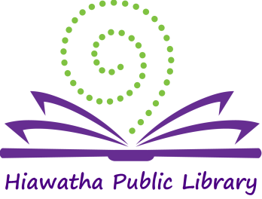

Library Board of Trustees Meeting

Location: Glenn Schminke Community Room
Date: July 10, 2018
Call to Order: 7:03 pm

- Call to Order – Roll Call Present: Matt Dunbar, Brenda Powers, Anna Ronnebaum, April Neuendorf, and Karlene Nesslage. Also present: Jeaneal Weeks-HPL Director, Rob Archibald – City Council Member
- Approval of Agenda
The Agenda was reviewed. Anna Ronnebaum made a motion to accept the agenda, Brenda Powers seconded and the motion carried.
- Approval of Consent Agenda
  - Approval of bills
  - Minutes: June 20, 2018
  - Library Director’s Report
  - Monthly Report
Unanimous approval was given for the Consent Agenda
- New Business
  - Election of Officers – President and Secretary
      - Nominations were accepted for President. Brenda Powers was nominated by Anna Ronnebaum, the motion was seconded by April Neuendorf. No other nominations were made. Voting was unanimous in favor of Brenda Powers for President.
      - Nominations were accepted for Secretary. Karlene Nesslage was nominated by Matt Dunbar; the motion was seconded by Anna Ronnebaum. No other nominations were made. Voting was unanimous in favor of Karlene Nesslage for Secretary.
  - Summer reading update
The summer reading program is going very well. A total of 2,208 people are participating. The 2 interns have helped with staffing this summer. The Library is busy all day long with patrons participating in many summer activities.
  - Patron Conduct Policy
The Patron Conduct Policy has been revised to bring it up to date. The board reviewed the revisions. A motion to accept the revised policy was made by Karlene Nesslage, Matt Dunbar seconded and the motion carried.
  - Board Training
Brenda Powers presented 3 opportunities during the next few months for the board members to attend classes for their continuing education requirements. The board will meet at the end of July for the 1st training session. These are conducted by the State Library of Iowa and will be remote sessions. The Iowa Library Association Conference will be held in Cedar Rapids this year, October 3-5, 2018.
- Old Business
  - Expansion update/fundraising update
Fundraising is continuing with donations/pledges topping $152,000. June 11th Jeaneal Weeks and Kim Downs will present to the Enhance Iowa board for the grant that has been applied for through that organization. Once the $2 Million goal is reached the project will be sent out for bids.
- General Discussion – Matt Dunbar will record the minutes for the August meeting in Karlene Nesslage’s absence.
- President’s Report – none
- Adjournment – Anna Ronnebaum made a motion to adjourn the meeting, Matt Dunbar seconded and the motion was carried. Meeting adjourned at 7:45 pm.

______________________
Brenda Powers, President
ATTEST:
___________________
Karlene Nesslage, Secretary

